1. Install Visual SVN 3.5 Version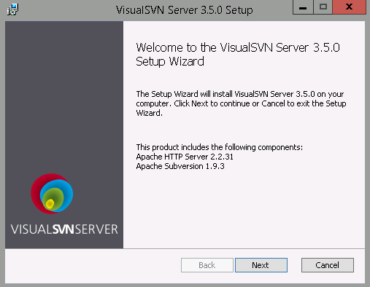
2. Accept the T&C and click next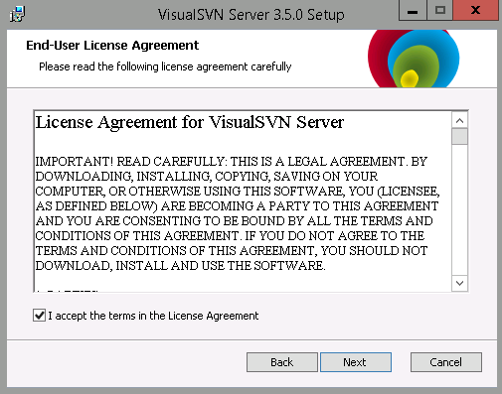
3. Choose Visual SVN Server and Administration Tools and click Next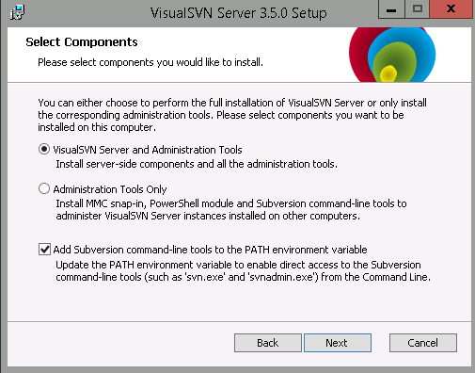
4. Click on Enterprise Edition and then put in the license key and click next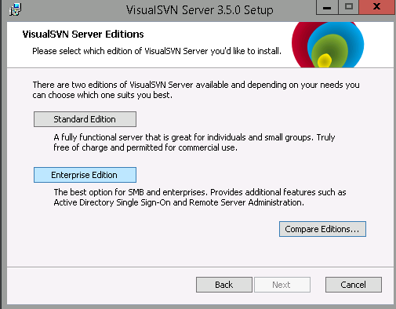
5. Now Put D:\apps\Visual SVN Server\ as installation directory & D:\data\Repositories as Repositories folder and click Next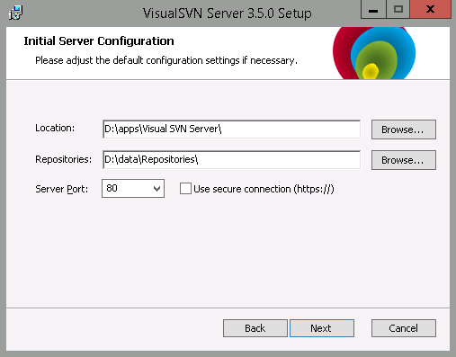
6. Start Installation by clicking on Install (Ensure you have admin privileges)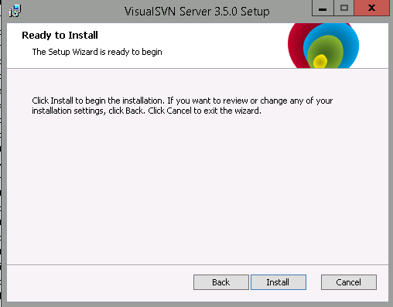
7. VisualSVN Server 3.5 is installed. Click on Finish and Start VisualSVN Server Manager.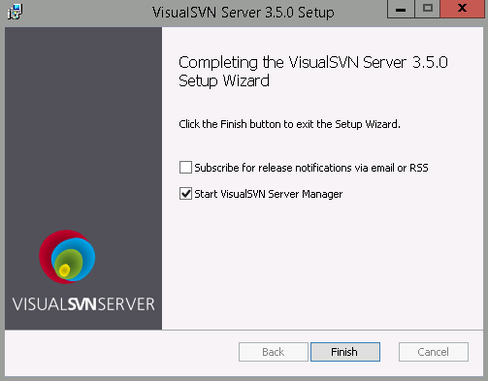
8. VisualSVN Server Manager is shown as below. Start configuration as per ETAS Standards.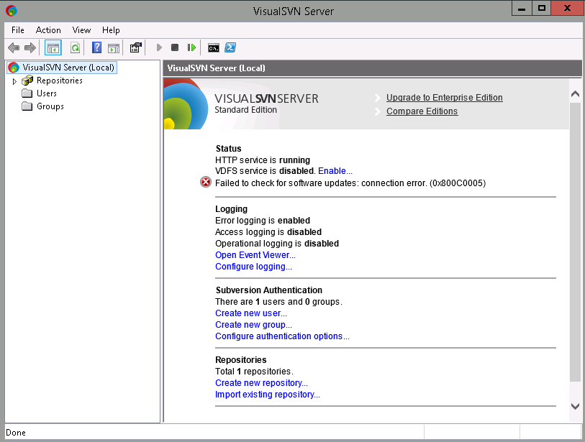
9. Before enabling the VDFS Service. Please provide necessary permissions for this feature to be enabled under Windows Firewall for access between the master and slave repositories.

* Enable or configure the Windows Firewall for access between the master and slave for replication using VisualSVN VDFS functionality.
  + Goto Control Panel 🡪 All Control Panel Items 🡪 Windows Firewall

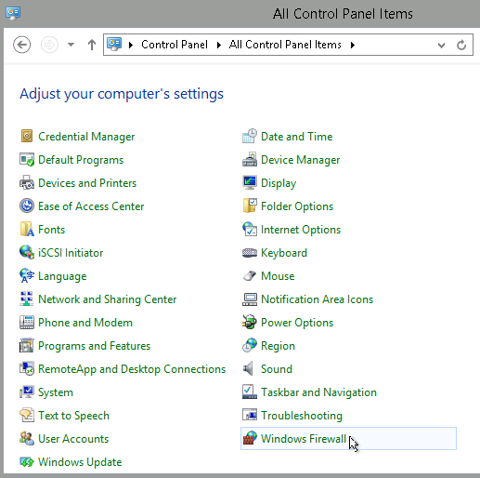

* + Click on „Allow an app or feature through Windows Firewall“

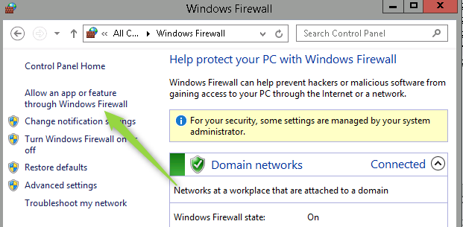

* + Using your admin privileges, Click on Change Settings

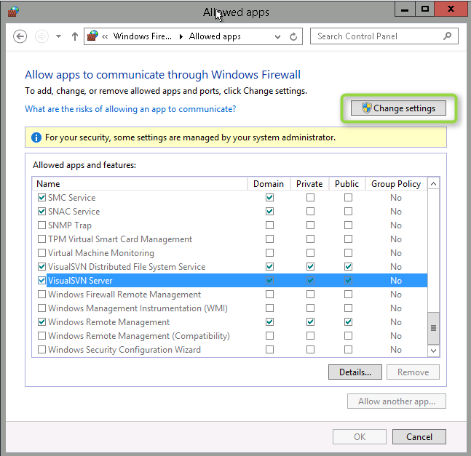

* + Check the boxes provided for VisualSVN Distributed File System Service and VisualSVN Server under Domain, Private and Public.

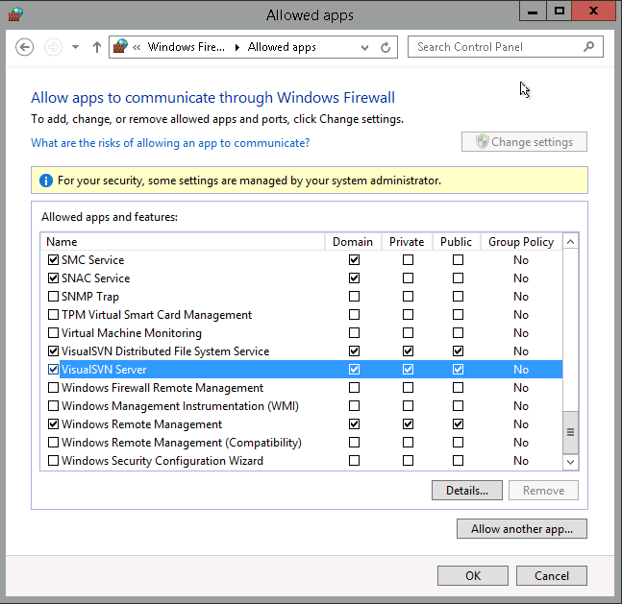

* + Click on OK button to save the changes.
* After the above step, enable the VDFS on the VisualSVN Server and it should be enabled without any error/issues.

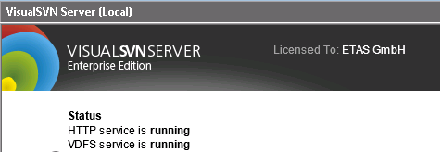

1. After the VisualSVN Server is up and running, You can configure the VDFS Service if there is a concept of master and slave in your design.